REPORT

CUSTOMER'S REF NO:
ALS THAILAND REF NO.: | ATT/ELP/14/3959A-H
ALS SINGAPORE REF NO.: | ATS/ELT/0176/15
DATE: | 16 March 2015
COMPANY: | Altum Precision Co., Ltd.
 | 133 Moo 1, Hi-Tech Industrial Estate Asia – Nakornsawan Road
 | T.Banlane A.Bangpa-in, Ayutthaya 13160
DATE SAMPLE RECEIVED: | 10 February 2015
DATE ANALYZED: | 10 March 2015
DATE TEST COMPLETED: | 13 March 2015

SAMPLE DESCRIPTION: | Description: Base Plate 3.5" FA Sample
 | Model: Eiger 6TB
 | Surface Area: 549 cm2
 | Remark: test on Machining area
METHOD:
Particle Analysis by SEM EDX | Taped Area For Drive Parts | No. of Times Taped | Surface Area Analysed (cm2) | Particle Ranges
Procedure No:  2092-701412 Rev. AE | Base | 20 | 0.02090 | 0.5um - 5.0um
RESULTS:
The Specification is based on WD's specification Doc No 96-004575 Rev.AX for Machined / Cast Base / (Aluminium) (3.5" Enterprise)
Test | Particle Classification | Result  (Particles/cm2) | Specification Limit  (Particles/cm2) | PASS / FAIL
Particle Analysis by SEM EDX | Total Hard Particles | 4 | NA | NA
Particle Analysis by SEM EDX | Total MgSiO Particles | 0 | NA | NA
Particle Analysis by SEM EDX | Total Steel Particles | 7 | NA | NA
Particle Analysis by SEM EDX | Total Magnetic Particles | 0 | NA | NA
Total hard particles/cm2 = total no. of hard particles/(no. of times taped x surface area analysed)
Stage Mimic of Base
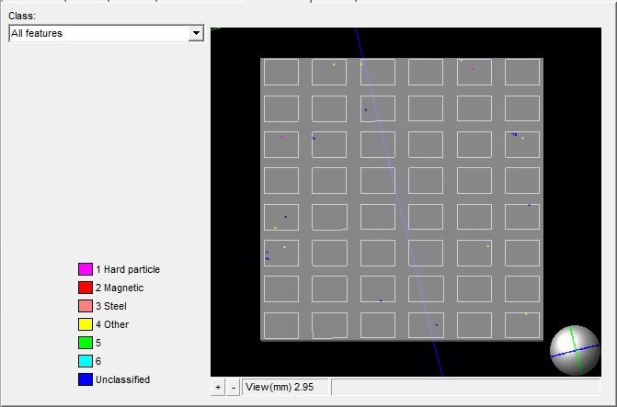
Please refer to attachment for details of results
Note: This report was performed test by ALS Singapore.

ALS THAILAND REF NO.: | ATT/ELP/14/3959A-H
ALS SINGAPORE REF NO.: | ATS/ELT/0176/15
DATE: | 16 March 2015
COMPANY: | Altum Precision Co., Ltd.

Analysis Table on Base
Elemental Composition | Count | Particle/cm2 | Remarks
Hard Particles
Al-Mg-O (0.5<=ECD<=2.0 um) | 0 | 0
Al-Ti-O (0.5<=ECD<=2.0 um) | 1 | 2
Al-Si-O (0.5<=ECD<=2.0 um) | 0 | 0
Si-O | 1 | 2
Al-Si-Cu-O (0.5<=ECD<=2.0 um) | 0 | 0
Al-Si-Fe-O (0.5<=ECD<=2.0 um) | 0 | 0
Ti-C | 0 | 0
Ti-O | 0 | 0
W-O | 0 | 0
Al-O (0.5<=ECD<=2.0 um) | 0 | 0
Al-Si-Mg-O (0.5<=ECD<=2.0 um) | 0 | 0
Al-Cu-O (0.5<=ECD<=2.0 um) | 0 | 0
Zr-C | 0 | 0
Zr-O | 0 | 0
Ti-B | 0 | 0
Ti-N | 0 | 0
W-C | 0 | 0
Al-Cu-O (2.0<ECD<=5.0 um) | 0 | 0
Al-Mg-O (2.0<ECD<=5.0 um) | 0 | 0
Al-O (2.0<ECD<=5.0 um) | 0 | 0
Al-Si-Cu-O (2.0<ECD<=5.0 um) | 0 | 0
Al-Si-Fe-O (2.0<ECD<=5.0 um) | 0 | 0
Al-Si-Mg-O (2.0<ECD<=5.0 um) | 0 | 0
Al-Si-O (2.0<ECD<=5.0 um) | 0 | 0
Al-Ti-O (2.0<ECD<=5.0 um) | 0 | 0
Pb-Zr-Ti (PZT) | 0 | 0
Si-C | 0 | 0
Subtotal - Hard Particles Only | 2 | 4
Magnetic Particle
Fe-Sm | 0 | 0
Fe-Nd | 0 | 0
Fe-Sr | 0 | 0
Ni-Co | 0 | 0
Sm-Co | 0 | 0
Ce-Co | 0 | 0
Nd-Pr | 0 | 0
Subtotal - Magnetic Particles Only | 0 | 0
Subtotal- Hard Particles including Magnetic Partilces | 2 | 4

ALS THAILAND REF NO.: | ATT/ELP/14/3959A-H
ALS SINGAPORE REF NO.: | ATS/ELT/0176/15
DATE: | 16 March 2015
COMPANY: | Altum Precision Co., Ltd.

Analysis Table on Base
Elemental Composition | Count | Particle/cm2 | Remarks
Steel Particle
Fe-Cr | 0 | 0
Fe-Cr-Ni | 1 | 2
Fe-Cr-Ni-Si | 0 | 0
Fe-Mn | 0 | 0
Fe-Ni | 0 | 0
Fe-Cr-Mn-S | 0 | 0
Fe-Cr-Ni-Mn | 0 | 0
Fe | 2 | 5
Fe-O | 0 | 0
Subtotal - Steel Particle Only | 3 | 7
Other Particle
Cu-S-Al-O Base | 0 | 0
No Element | 0 | 0
SCrMn/Fe | 0 | 0
Ti-O/Al-Si-Fe | 0 | 0
Ni | 0 | 0
Ni-P | 0 | 0
Sn base | 0 | 0
Other | 6 | 14
Al | 0 | 0
Al-Mg | 0 | 0
Al-Ti-Si | 0 | 0
Al-Cu | 0 | 0
Al-Si-Cu | 0 | 0
Al-Si/Fe | 0 | 0
Al-Si-Mg | 0 | 0
Mg-Si-O-Al | 0 | 0
Mg-Si-O | 0 | 0
Ti Base | 0 | 0
Cr-O | 1 | 2
Na-Cl | 0 | 0
Cu | 0 | 0
Cu-Au | 0 | 0
Ag-S | 0 | 0
Au-Ni | 0 | 0
Cu-Au-Ni | 0 | 0
Cu-Zn Base | 0 | 0
Cu-Zn-Ni | 0 | 0
Cu-Zn-Au-Ni | 0 | 0

ALS THAILAND REF NO.: | ATT/ELP/14/3959A-H
ALS SINGAPORE REF NO.: | ATS/ELT/0176/15
DATE: | 16 March 2015
COMPANY: | Altum Precision Co., Ltd.

Elemental Composition | Count | Particle/cm2 | Remarks
Other Particle
Zn | 0 | 0
Pb | 0 | 0
Fe-Cu | 0 | 0
Cr-Mn | 0 | 0
F-O | 0 | 0
Al-Si Base | 0 | 0
NiP/Al | 0 | 0
NiP/Fe | 0 | 0
NiP Base | 0 | 0
Ba-S Base | 0 | 0
Al-S/Si | 0 | 0
AlSi/K | 0 | 0
Ca | 0 | 0
AlSi/Fe-Cr-Mn-Cu | 0 | 0
Cu-Zn | 0 | 0
Cu-S | 0 | 0
Fe-Cr/S | 0 | 0
Sb Base | 0 | 0
Subtotal - Orther Particle Only | 7 | 16
Grand Total of Particles | 12 | 27

ALS Testing Services
(Thailand) Co.,Ltd.
-----------------------------------
Warunee Maneesuwan
M.Sc, B.Sc, Laboratory Manager

